Senegal

## Freedom House political status

The data set shows the Freedom House political scores and status of the country each year.

## # A tibble: 19 x 5  
## country iso3c date mean status   
## <chr> <chr> <dbl> <dbl> <chr>   
## 1 Senegal SEN 1996 4 Partly Free  
## 2 Senegal SEN 1998 4 Partly Free  
## 3 Senegal SEN 2000 3.5 Partly Free  
## 4 Senegal SEN 2002 2.5 Free   
## 5 Senegal SEN 2003 2.5 Free   
## 6 Senegal SEN 2004 2.5 Free   
## 7 Senegal SEN 2005 2.5 Free   
## 8 Senegal SEN 2006 2.5 Free   
## 9 Senegal SEN 2007 2.5 Free   
## 10 Senegal SEN 2008 3 Partly Free  
## 11 Senegal SEN 2009 3 Partly Free  
## 12 Senegal SEN 2010 3 Partly Free  
## 13 Senegal SEN 2011 3 Partly Free  
## 14 Senegal SEN 2012 2.5 Free   
## 15 Senegal SEN 2013 2 Free   
## 16 Senegal SEN 2014 2 Free   
## 17 Senegal SEN 2015 2 Free   
## 18 Senegal SEN 2016 2 Free   
## 19 Senegal SEN 2017 2 Free

## Freedom House classification of political change

The data set shows the GDP growth and the ecomic growth classification of the country each year.

## # A tibble: 19 x 4  
## country iso3c date politicalChangeFH  
## <chr> <chr> <dbl> <chr>   
## 1 Senegal SEN 1996 no change   
## 2 Senegal SEN 1998 no change   
## 3 Senegal SEN 2000 democratization   
## 4 Senegal SEN 2002 democratization   
## 5 Senegal SEN 2003 no change   
## 6 Senegal SEN 2004 no change   
## 7 Senegal SEN 2005 no change   
## 8 Senegal SEN 2006 no change   
## 9 Senegal SEN 2007 no change   
## 10 Senegal SEN 2008 autocratization   
## 11 Senegal SEN 2009 no change   
## 12 Senegal SEN 2010 no change   
## 13 Senegal SEN 2011 no change   
## 14 Senegal SEN 2012 democratization   
## 15 Senegal SEN 2013 democratization   
## 16 Senegal SEN 2014 no change   
## 17 Senegal SEN 2015 no change   
## 18 Senegal SEN 2016 no change   
## 19 Senegal SEN 2017 no change

## Freedom House score trend

The plot shows the Freedom House scores trend of the country.

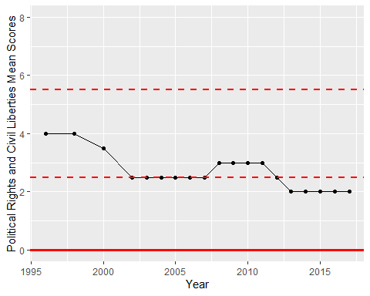

Freedom House Score Trend